SOFTWARE ENGINEERING
NOTHING CHATS

Students: Raul Bărbosu
Alin Costuț

Professor: Crișan-Vida Mihaela Marcella

Semester 1
2025-2026

Table of Contents

1. Project Description 3
2. UML Use Case Diagram 4
3. Design Pattern and Motivation 5
4. UML Class Diagrams 6
5. UML Sequence Diagrams 9
6. Application Architecture 14
6.1. High-Level Conceptual (3-Tier) 14
6.2. Frontend-Specific Architecture 15
6.3. Backend-Specific Architecture 16
7. Project Structure 17
7.1. Important snippets of code 18
8. Project Visuals 19
9. Project Repository 20

1. Project Description

This is a full-featured real-time chat application built on the MERN stack that enables users to communicate instantly through a modern, intuitive interface. The platform provides secure user authentication, live messaging capabilities, and rich media sharing. Users can see when their contacts are online, receive visual and audio notifications for new messages, and enjoy a polished user experience with customizable settings. The application handles everything from user registration with welcome emails to real-time typing indicators, creating a complete communication solution suitable for personal or professional use.
The application is built on the MERN stack (MongoDB, Express, React, Node.js) with a clear separation between frontend and backend. On the server side, Node.js and Express power a RESTful API protected by custom JWT authentication, eliminating reliance on third-party auth services. MongoDB stores user data, messages, and media references persistently, while Socket.io establishes WebSocket connections to enable real-time bidirectional communication for instant messaging, online/offline status updates, and typing indicators. Arcjet middleware provides rate-limiting to prevent abuse, and Resend handles transactional welcome emails upon user registration. Image uploads are managed through Cloudinary integration, offloading storage to a CDN.
The frontend leverages React for component-based UI development, styled with Tailwind CSS and DaisyUI for a responsive, modern interface. Zustand manages application state efficiently across components, handling user sessions, message histories, and UI preferences like notification sound toggles. The Socket.io client maintains persistent connections to the backend, listening for events and updating the UI in real-time without page refreshes, creating a seamless chat experience.

2. UML Use Case Diagram

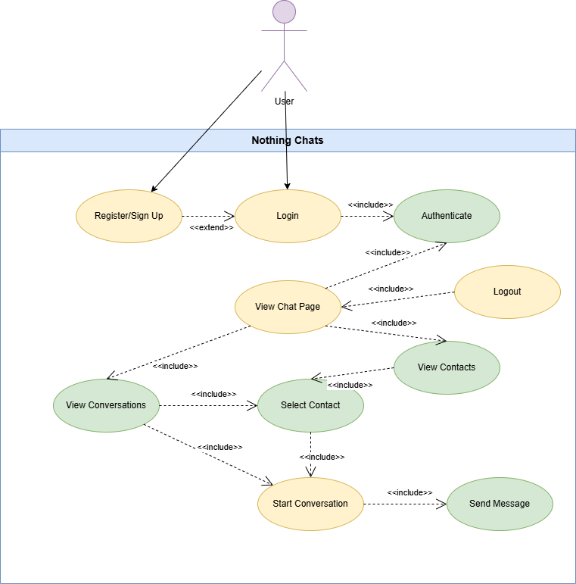

3. Design Pattern and Motivation

This chat application is architected around the Observer Pattern, a behavioral design pattern that establishes a one-to-many dependency between objects. When the state of one object (the subject) changes, all its dependents (observers) are notified and updated automatically. This pattern forms the architectural backbone of our real-time communication system, enabling efficient, scalable, and loosely coupled message distribution across multiple connected clients.

The Observer Pattern in Context
Pattern Definition
The Observer Pattern consists of two primary components:

- Subject (Observable): The entity that maintains a list of observers and notifies them of state changes
- Observers: Entities that subscribe to the subject and receive notifications when changes occur
In our chat application, the Socket.io server acts as the subject, while connected clients serve as observers that subscribe to various events such as new messages and online status updates.
Why the Observer Pattern?
Real-time messaging is fundamentally an event-driven, one-to-many communication problem. Consider the core scenarios our application must handle:
- Message Broadcasting: When one user sends a message, multiple recipients must be notified instantly
- Presence Updates: When a user comes online or goes offline, all contacts need to see the status change
- Typing Indicators: When someone starts typing, other participants in the conversation should be informed
- Notification Delivery: Multiple UI components need to react to incoming messages without tight coupling
Each of these scenarios requires notifying multiple parties about a single event, precisely what the Observer Pattern excels at.

4. UML Class Diagrams

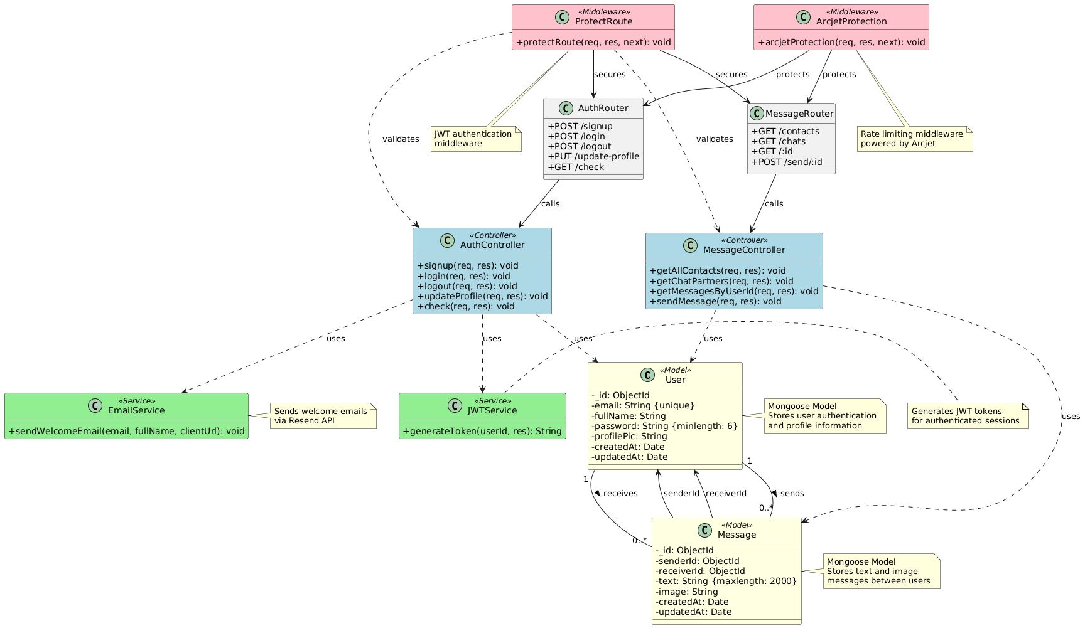

5. UML Sequence Diagrams
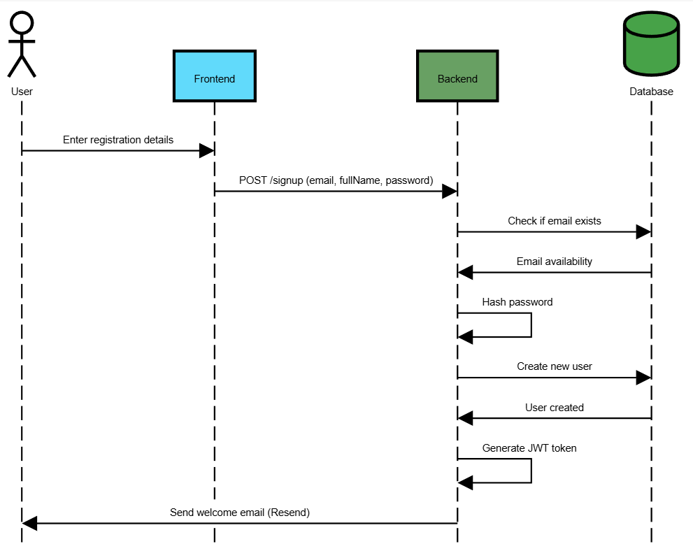
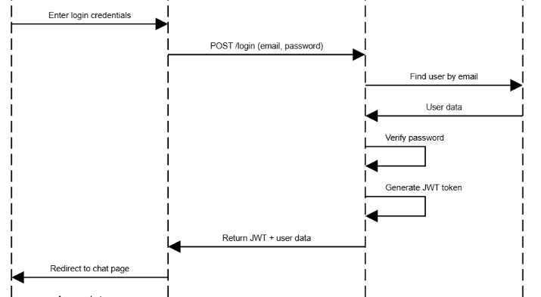

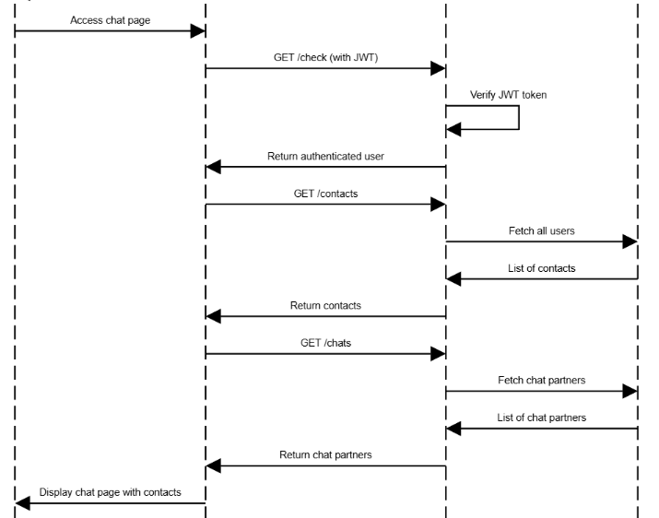
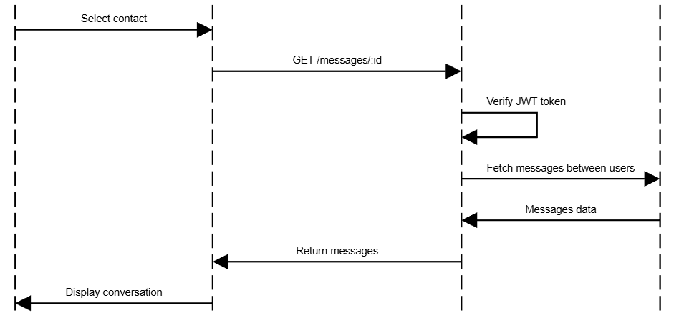
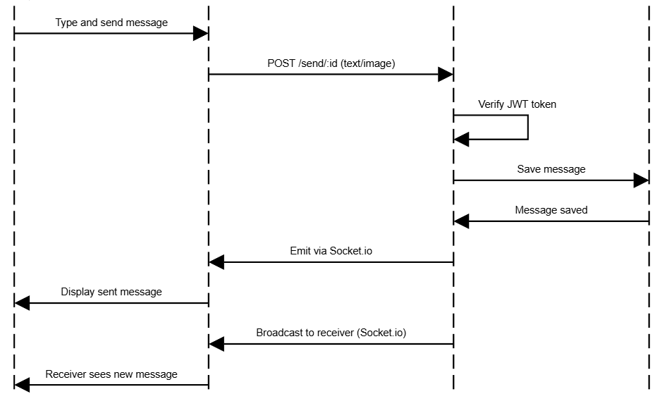
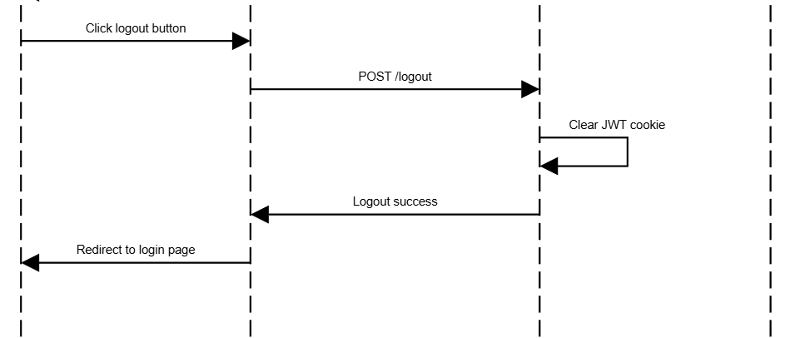

6. Application Architecture

6.1. High-Level Conceptual (3-Tier)
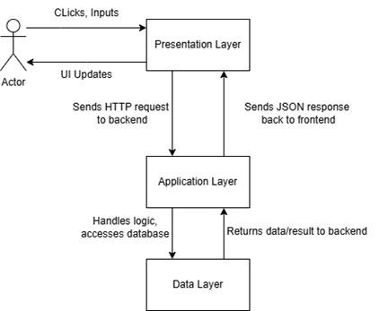

6.2. Frontend-Specific Architecture
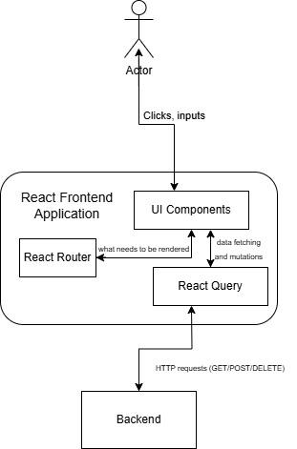

6.3. Backend-Specific Architecture
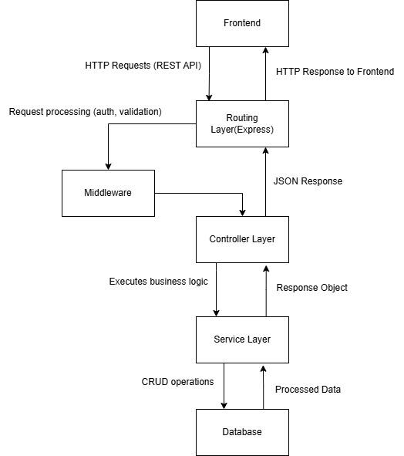

7. Project Structure

We separated the frontend and backend into 2 separate folders, and then we made sure to further separate code into specific folders based on their functionality, so that it’s easier to understand what a specific piece of code does.

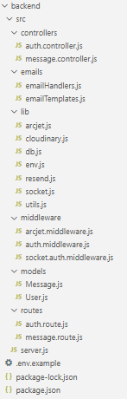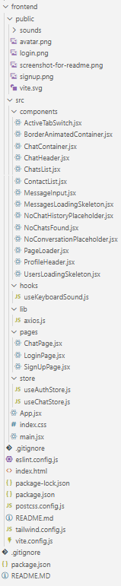

7.1. Important snippets of code

The Login implementation in the backend.

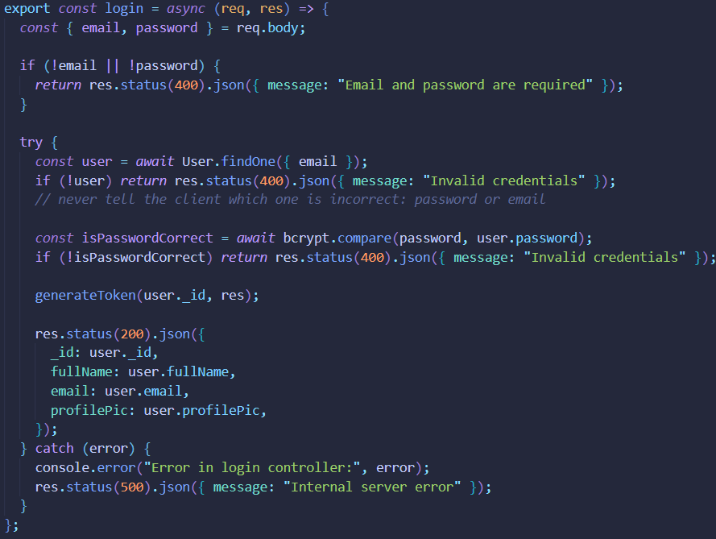

Implementing socket.io.

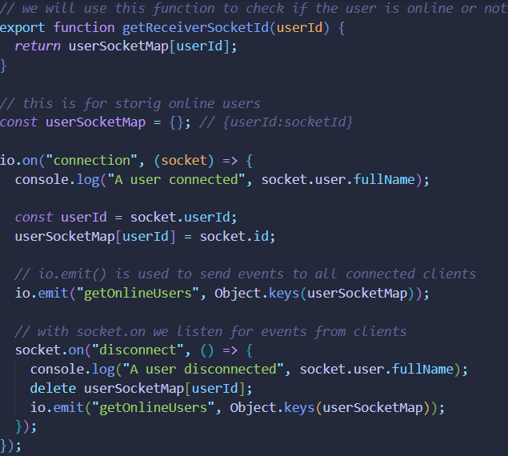

Sending message implementation

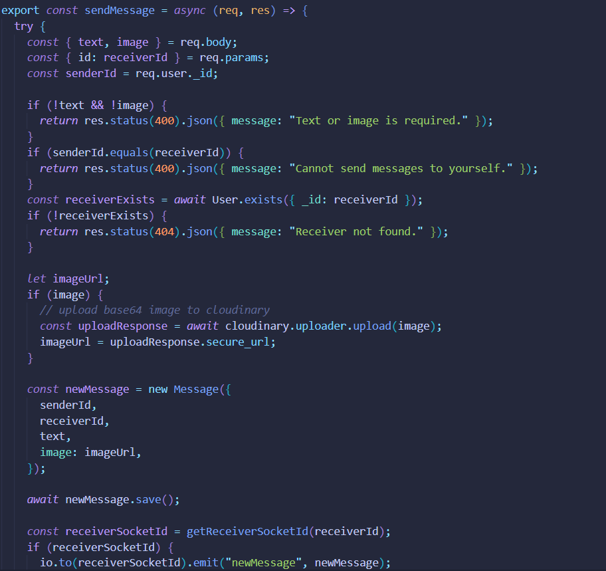

8. Project Visuals

The login page.

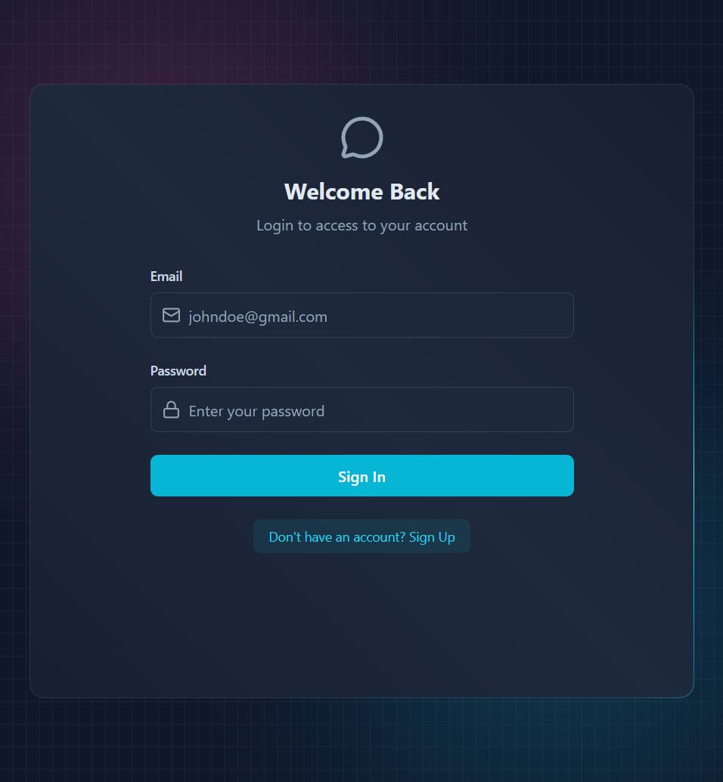

Chat windows on both ends.

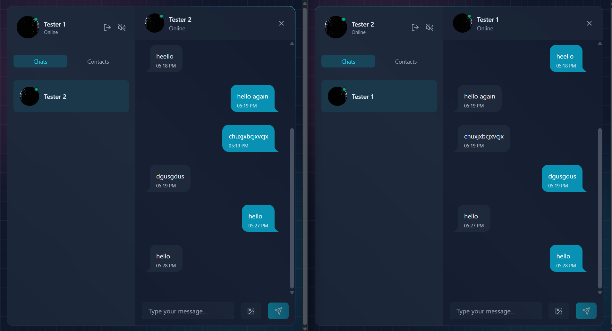

9. Project Repository
https://github.com/RaulB312/Nothing-Chats

